UNIVERSITY OF MADRAS
PATRICIAN COLLEGE OF ARTS AND SCIENCE
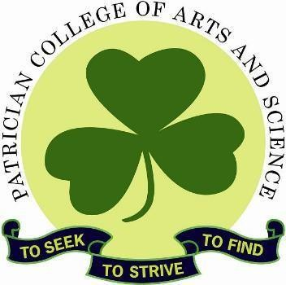
Adyar, Chennai –600 020


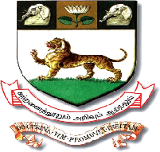

AI-Augmented Backend Development - A&S

TN Skills Project Record

BY

PROJECT TITLE : AI Fit Track API

College Code : unm1611

1.Kaviya sri.k
(kaviyakamal522@gmail.com) (7E9E64EC19116A5BEBF4A898FBF8FDE)

2.Reshma.k
(r80700854@gmail.com) (BB0626388417298914E42BF6C5556470)

3.Ramya.R
(ramya010807@gmail.com) (B8A6C91B2A45425A0A54B64EEF6E96E4)

4.subasree.S
(subasudhagar96@gmail.com) (58F144BE64B3A08B00148A465AE7F590)

DEGREE : BACHELOR OF COMPUTER APPLICATIONS YEAR: II YEAR – 3rd SEMESTER (2026-2027)

Project GitHub Repository:

UNIVERSITY OF MADRAS
PATRICIAN COLLEGE OF ARTS AND SCIENCE
Adyar, Chennai –600020

A Project report submitted in partial fulfillment of the requirement for the award of the Degree of

BACHELOR OF COMPUTER APPLICATIONS

TN Skills Project Record
AI Fit Track API
Submitted By

1.Kaviya sri K

(kaviyakamal522@gmail.com) (7E9E64EC19116A5BEBF4A898FBF8FDE)

2.Reshma K

(r80700854@gmail.com) (BB0626388417298914E42BF6C5556470)

3.Ramya R

(ramya010807@gmail.com) (B8A6C91B2A45425A0A54B64EEF6E96E4)

4.subasree S

(subasudhagar96@gmail.com) (58F144BE64B3A08B00148A465AE7F590)

A Christian Minority Institution

Affiliated to the University of Madras & Reaccredited ‘A+’ Grade by NAAC Ranked No. 1 in Tamil Nadu & 17th in India among Top Non-Autonomous Colleges by Education World Awarded 4-star Rating with Mentor Status, Ministry of Education, Government of India.
Railway Station, 3, Canal Bank Road, Gandhi Nagar, Behind Kotturpuram, Adyar, Chennai, Tamil Nadu 600020.

November 2026

